Supporting Information

In silico prediction of hERG blockers using machine learning and deep learning approaches

Yuanting Chen, Xinxin Yu, Weihua Li, Yun Tang*, Guixia Liu*

Shanghai Frontiers Science Center of Optogenetic Techniques for Cell Metabolism, Shanghai Key Laboratory of New Drug Design, School of Pharmacy, East China University of Science and Technology, 130 Meilong Road, Shanghai 200237, China

* To whom correspondence should be addressed.
Tel: +86-21-64250811
Fax: +86-21-64251033
Email: gxliu@ecust.edu.cn (G. Liu), ytang234@ecust.edu.cn (Y. Tang)

Contents
Machine learning methods

Graph convolutional neural network

Figure S1. Architecture of GCN

Machine learning methods
In this study, four machine learning algorithms, K-nearest neighbor (KNN), Support vector machine (SVM), Random forest (RF), and Neural network (NN) were used to construct the models. The four methods are described below.
K-nearest neighbor (KNN)
The K-nearest neighbors (KNN) is a commonly used nonparametric method in the computation of drug design, which is theoretically mature and also the simplest machine learning algorithm in principle (Laaksonen & Oja, 1996). This method specifies the class of each test data based on the class of the k most adjacent samples in the training set to the test set, and the class is equal to the class to which most of the k nearest neighbor samples belong. In our study, the k-value was selected from the range of 3-10.
Support vector machine (SVM)
Support vector machine (SVM) is a supervised machine learning method proposed by Vapnik and Cortes in 1995 (Cortes & Vapnik, 1995), which has many advantages in solving nonlinear, small-sample, and high-dimensional pattern recognition problems. SVM uses a kernel function to project the original data points from the input space to a high-dimensional or even infinite-dimensional feature space, and then finds an optimal hyperplane to separate different classes of data points based on the principle of distance maximization. Commonly used kernel functions include Linear Kernel, Polynomial Kernel, Gaussian Radial Basis Function (RBF) Kernel, and Sigmoid Kernel, and the appropriate kernel function needs to be selected for dimension raising according to different situations when dealing with practical problems. In our study, the RBF kernel was chosen to raise the dimension and we use a grid search to seek the optimal pair of the penalty parameter C and kernel parameter γ。
Random forest (RF)
Random forest (RF) is a method that integrates many decision trees to form a forest and is used to predict the outcome (Breiman, 2001). Specifically, to classify an input sample, it is entered into each decision tree for classification, and each decision tree represents a judgment criterion for classification. Then, N trees correspond to N classification results, and the random forest collects all the classification results and outputs the category with the highest number of votes. We set the value of N to a multiple of 10 between 10 and 101 for the grid search.
Neural network (NN)
Neural network (NN) was first proposed by McCulloch and Pitts in 1940, and it is based on the working principles of the human brain (McCulloch & Pitts, 1990). The neural network structure consists of many basic information units, i.e. neurons, divided into an input layer, a hidden layer, and an output layer. The input layer is responsible for receiving signals, the hidden layer is responsible for decomposing and processing the data, and the classified results are presented in the output layer. In this study, a neural network consisting of an input layer, a hidden layer, and an output layer is used to build the model.
Graph convolutional neural network
GCN is a type of neural network designed for graph data. GCN uses convolutional layers to aggregate information from the neighboring nodes in a graph (Kipf & Welling, 2017). It has been successfully applied to a variety of applications including social network analysis, drug discovery, and recommendation systems. The GCN model used in this study comprises two convolutional layers, which perform a local operation on the input graph by applying a set of learnable filters or kernels to small regions of the graph. Each convolutional layer contains 64 kernels, which means that the model is capable of extracting 64 distinct types of features from the input graph. In Figure S1, the small square in the input diagram represents a kernel. After the convolutional layer, there is a pooling layer to reduce the size of the parameter matrix, which can speed up calculations and prevent overfitting. Finally, the output from the pooling layer is fed into a dense layer, which consists of 128 neurons. The dense layer performs a global operation on the input features and outputs a vector of 128 values, which can be further processed by downstream layers for making predictions or classifications.

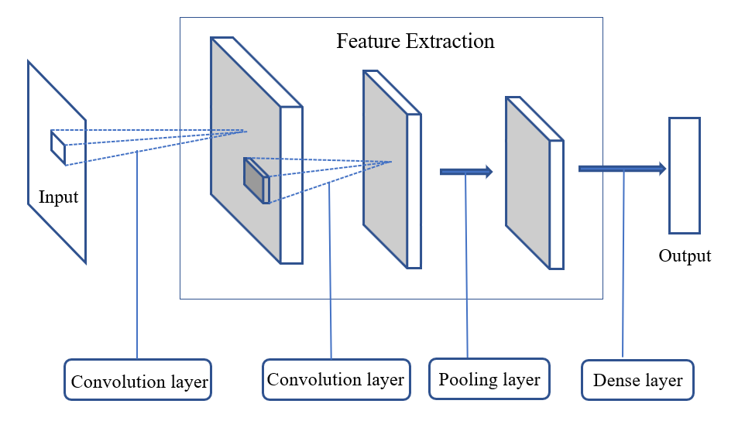
Figure S1. Architecture of GCN

Reference
Breiman, L. (2001). Random Forests. Machine Learning, 45(1), 5-32. doi: 10.1023/A:1010933404324
Cortes, C., & Vapnik, V. (1995). Support-vector networks. Machine Learning, 20(3), 273-297. doi: 10.1007/BF00994018
Kipf, T. N., & Welling, M. (2017). Semi-Supervised Classification with Graph Convolutional Networks (arXiv:1609.02907). arXiv. doi: 10.48550/arXiv.1609.02907
Laaksonen, J., & Oja, E. (1996). Classification with learning k-nearest neighbors. Proceedings of International Conference on Neural Networks (ICNN’96), 3, 1480-1483. doi: 10.1109/ICNN.1996.549118
McCulloch, W. S., & Pitts, W. (1990). A logical calculus of the ideas immanent in nervous activity. 1943. Bulletin of Mathematical Biology, 52(1-2), 99-115; discussion 73-97. doi: 10.1007/BF02478259

